Spring Interview Questions

Q – Why will you choose Spring Boot over Spring Framework?

A – Following are the key features Spring Boot provides over Spring Framework

1. Dependency Resolution/Avoid version conflict – Spring Boot provides starter dependency to resolve the dependency resolution and it inherits version from spring-boot-starter-parent version. Following are the list of starter dependency list: -
   1. spring boot starter web
   2. spring boot starter data JPA
   3. spring boot starter AOP
   4. spring boot starter web services
   5. spring boot starter security
   6. spring boot starter for Apache Kafka
   7. spring boot starter for Spring Cloud
   8. spring boot starter Thymeleaf
2. Avoid additional configuration.
3. Embedded Tomcat and Jetty (no need to deploy war files)
4. Provides production-ready features like metrics and health check.

Q – How will you run your Spring Boot application?

A – There are multiple ways to trigger the main method of Spring Boot application either by clicking the main method or by invoking the maven plugin command “mvn spring-boot: run” in console. This command executes the main method of application class from target classes folder.

If we execute the .jar file, jar file contains METAINF file, which contains all information like where is main class and it all dependency related information. Execution starts from the main class.

Q – What is the purpose of @SpringBootApplication annotation in Spring Boot application?

A - This annotation is the combination of following three annotations: -

* @EnableAutoConfiguration – will automatically configure various components for your application by just scanning your dependency and class path.
* @ComponentScan – enable component scanning in the package where is main class and its subpackages.
* @Configuration – It allow to register extra bean in the context or import additional configuration in the context.

Q – Can I use the above three annotations instead of @SpringBootApplication, if yes will my application work as expected?

A – Yes, It will work as expected

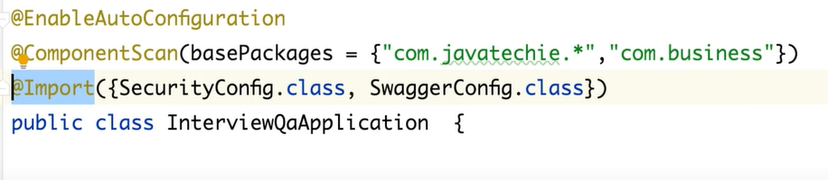

Q – How can you disable auto-configuration class in Spring Boot?

A – Auto-configuration can be disabled by excluding the class in @SpringBootApplication annotation

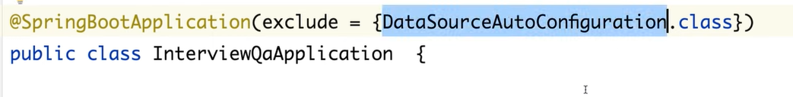

OR

By defining the class in application.properties or application.yml file with fully qualified class path

…

Q – How can you customize the default configuration in spring boot?

A – Default configuration can be customized by providing the configuration details in application.properties or application.yml file.

Q – How does the Spring Boot run() method works internally?ss

A – Spring Boot run() method triggered. It does follow things internally: -

* It loads the environment properties and checks the types of application it is.
* Based on the type of application it creates the ApplicationContext.
* It registers all the annotated beans into a specific context.
* At the end it kicks up the embedded tomcat container to run jar/war

Q – What is command line runner in Spring Boot?

A – Command -line runner will help you to execute pre-processing logic or execute your data setting logic.

If any thing you want to execute at the time of application startup, you need to define under run() method provided by commandLineRunner interface, in implementation class.

